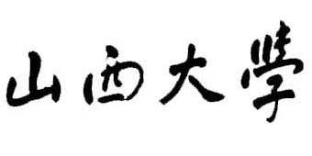


Guardian’s Certificate

This is to certify that I would like to be the Guardian of Mr. / Ms. for his/her study at School of International Education and Exchange of Shanxi University for the following conditions:

- The applicant will not be involved in any other affairs other than study and will be abide by Chinese laws.
- The applicant will study hard and will stick to school regulations and disciplines.
- The applicant will submit tuitions and fees on time and, if he/she can’t, the guardian is willingly responsible for this matter.
- The guardian is responsible for dealing with the accidental happenings during his/her study at School of International Education and Exchange of Shanxi University.

The Guardian’s Information:

Nationality:
Full name:
Permanent Address:
Phone No.:
Fax No.:
E-mail:

Signature of the Guardian:
Date:

